- Purpose
  - The purpose of this document is to describe the procedure for assembling a Foreman Dual Speed machine.
- Scope
  - This SOP applies to all equipment assembly team members. The process applies to the following machine ID’s:
E083010EQM0600BE1200 – Foreman 20DS Dual Speed Floor Machine 20”
E083010EQM0607BE1200 – Foreman 20DS Dual Speed Floor Machine 20”-Canada
- Responsibilities
  - The operations manager/supervisor is responsible for enforcing this SOP.
- Materials
  - The proper materials needed for this process are listed on the machine work order.
  - Hand/Power Tools
- Definitions

- Procedure
  - Start by placing the base (E81129) into the drill fixture as shown.

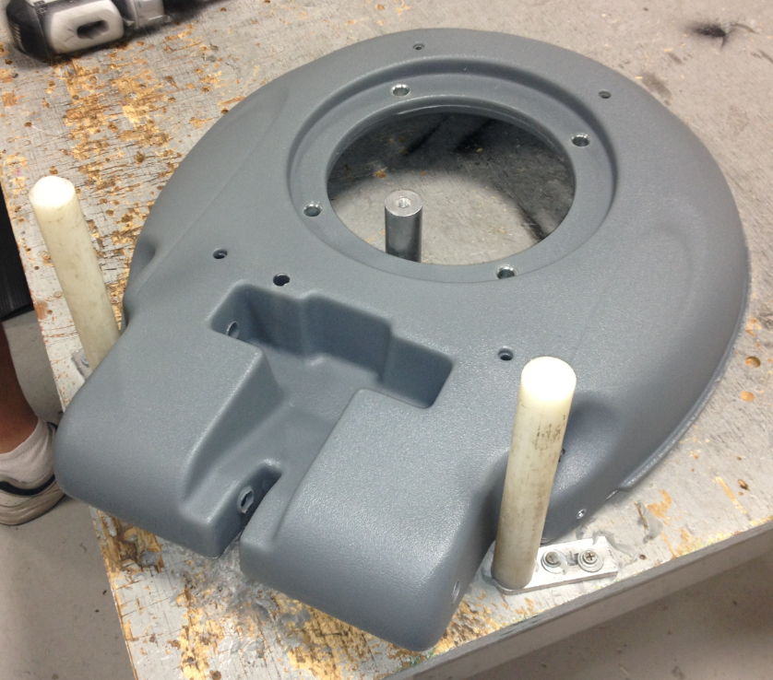

  - Use the long ½” drill bit provided and drill out the two holes in the base that the axles go through.

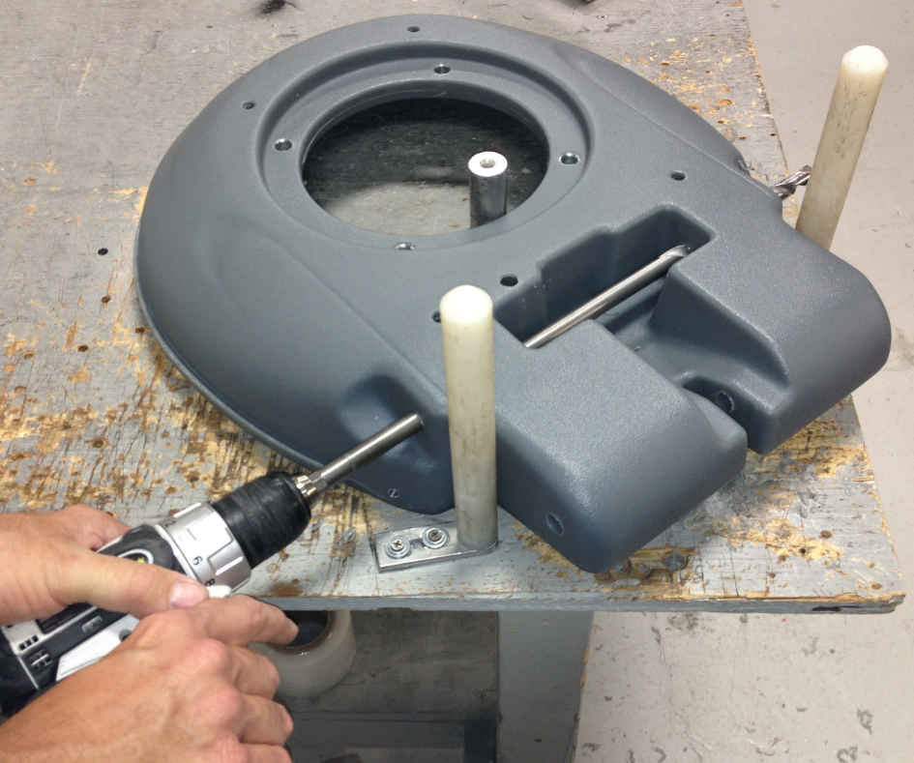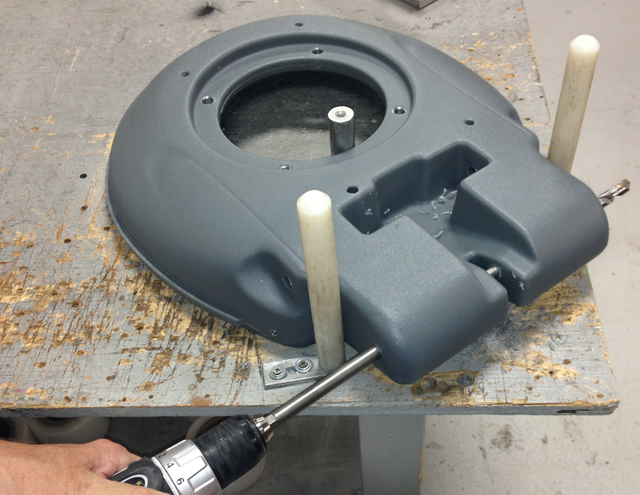

  - Use the ½” reamer provided and run it through the slot shown. Drilling the cross hole creates a burr in the slot that needs to be removed. Move the reamer back and forth until the burr has been cleared.

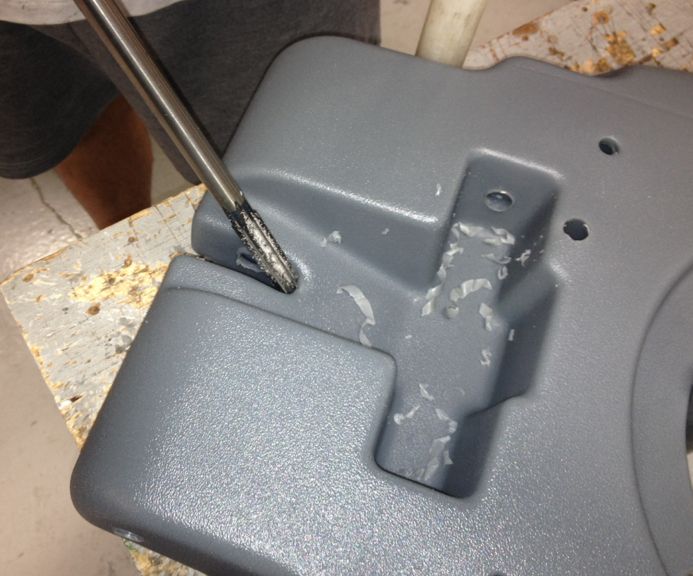

  - Place a motor (89989) onto the table as shown. Orient the cord towards the edge of the table as shown. NOTE: The actual motor used for a dual speed does not include capacitors.

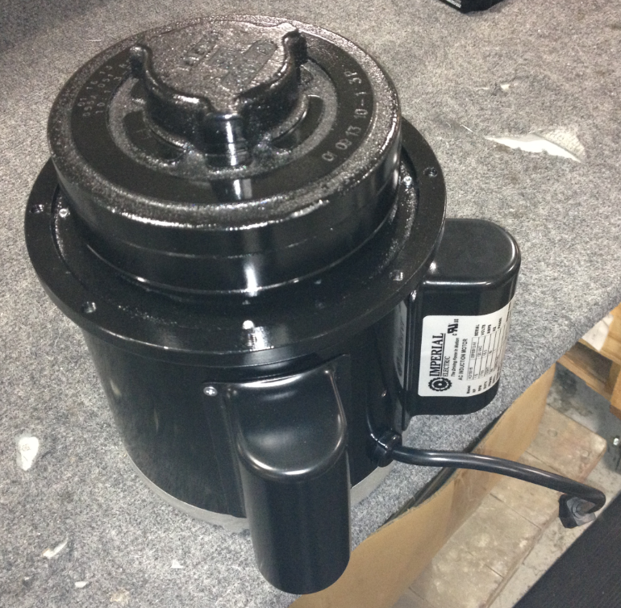

  - Place the drilled out base onto the motor in the orientation shown. This will keep the cord on the motor towards the rear of the machine.

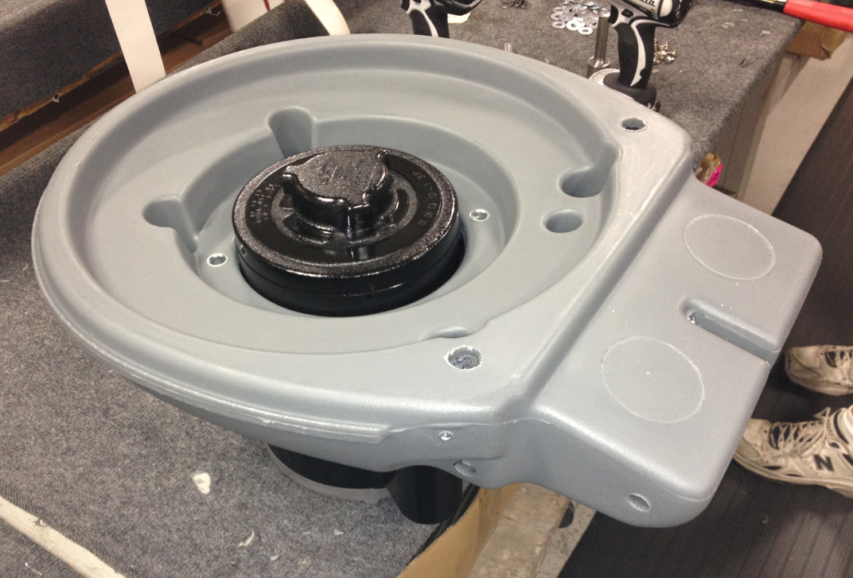

  - Bolt the machine base to the motor using 4 bolts (83641), 4 lock washers (81067), and 4 flat washers (81062). Put some blue loc-tite onto the threads before installing. You may need to check the holes for obstructions first.

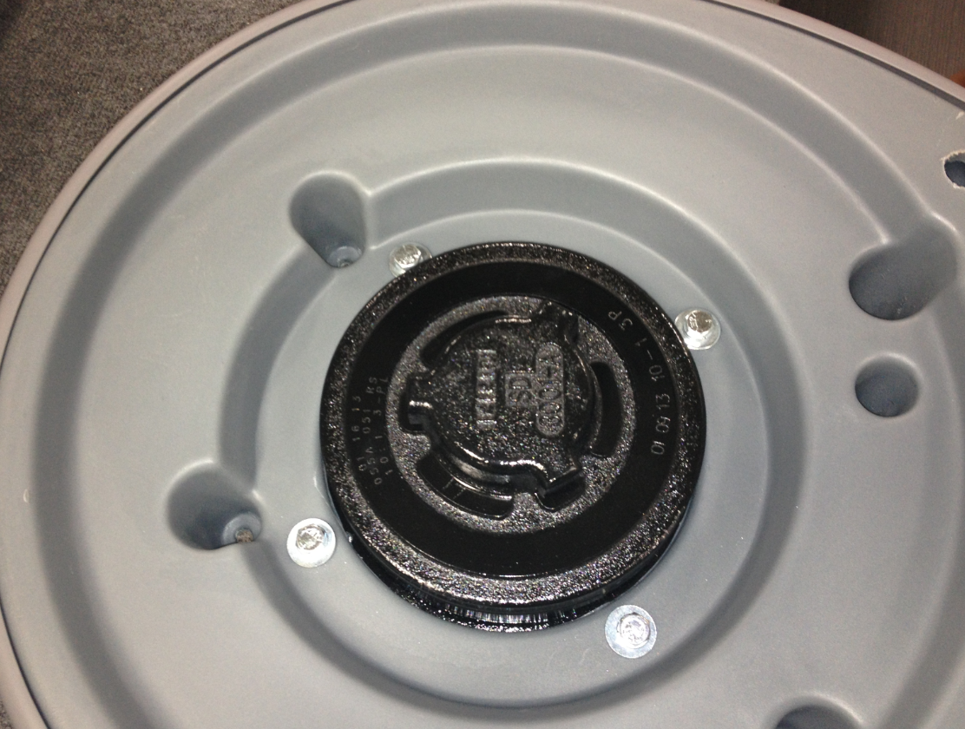

  - Install the bumper (E83141) as shown using a bolt (83425) and a washer (81068) on each end. Install the bolts and then stretch the bumper of the front of the base as shown. Be sure that it properly snaps into place.

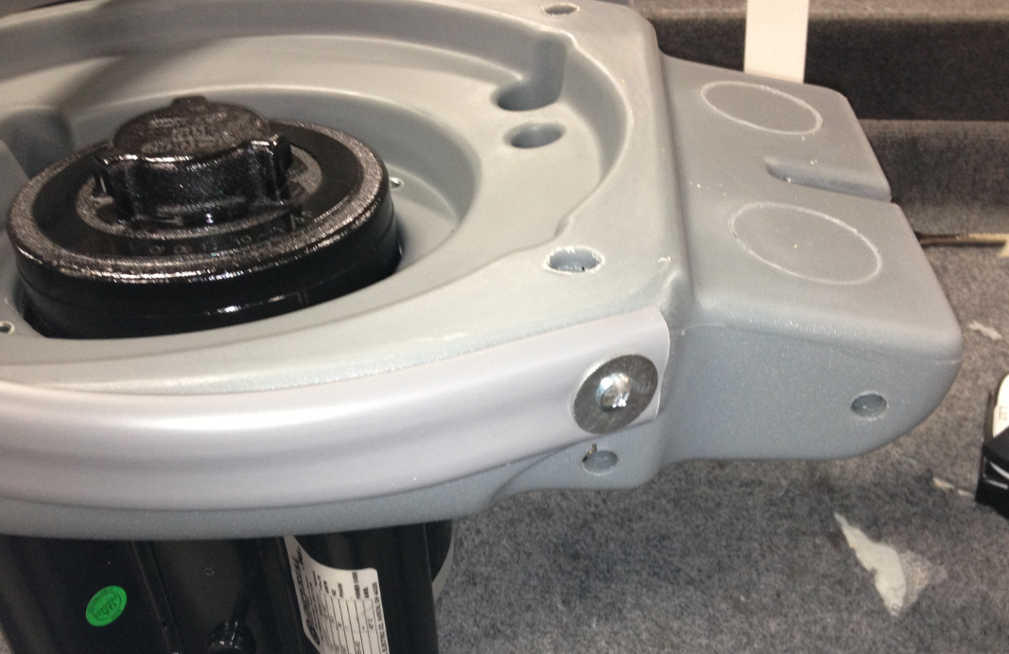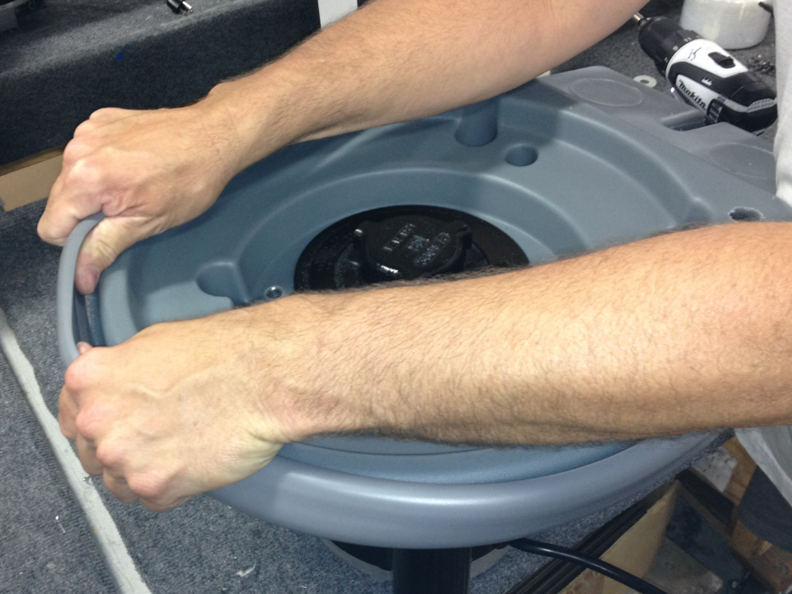

  - Use a hand drill to install the rear axle (83379) into the hole shown. Only install the axle ½ way at this point.

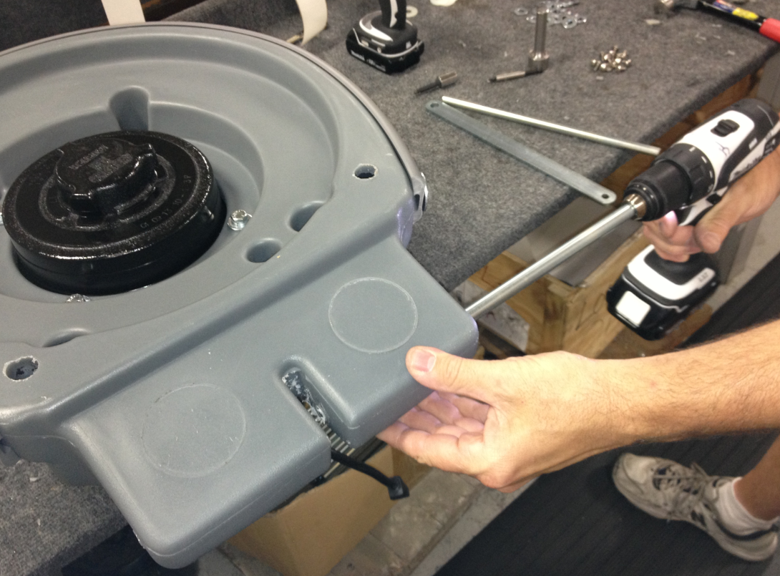

  - In the middle slot in the base, place a flat handle bracket (83136) sandwiched between 2 nylon washers (83145). Once these are in place, continue installing the axle through them and out the other side of the base.

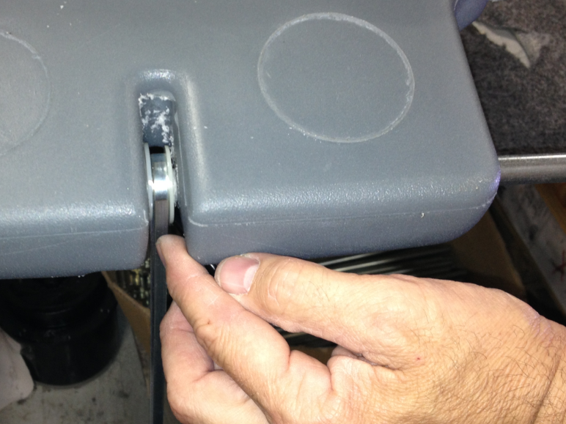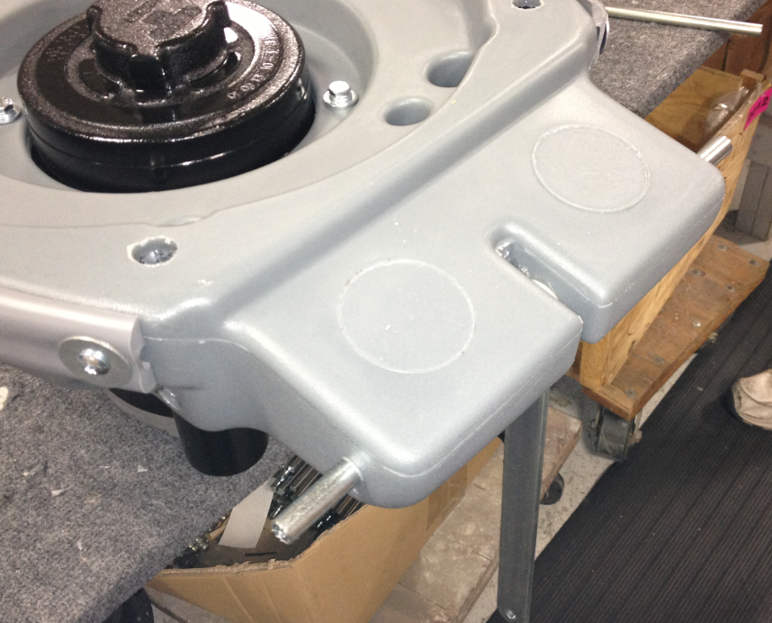
Bracket
Washer
Washer

  - Place a wave washer (83269) onto each end of the axle as shown (2 total). Once that is complete, place a nylon washer (83145) onto each end of the axle as shown (2 total).

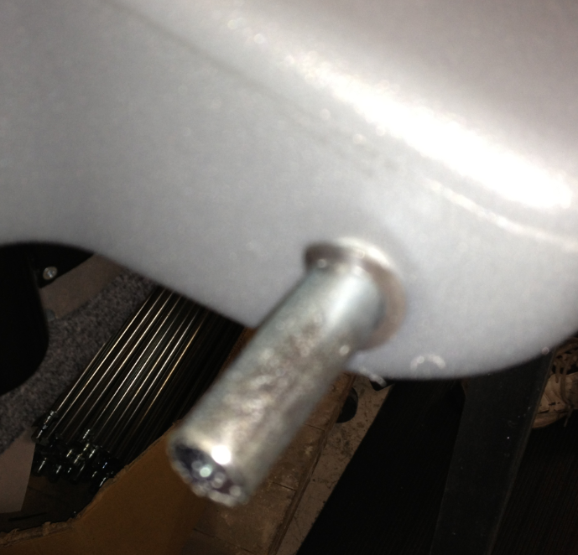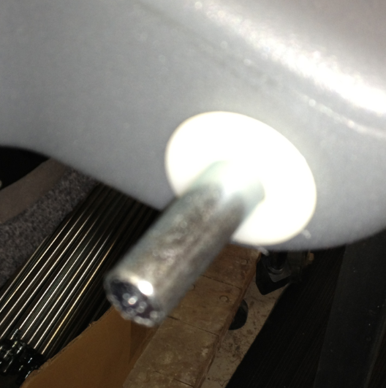

  - Place a 5” wheel (81124) onto each end of the axle as shown.

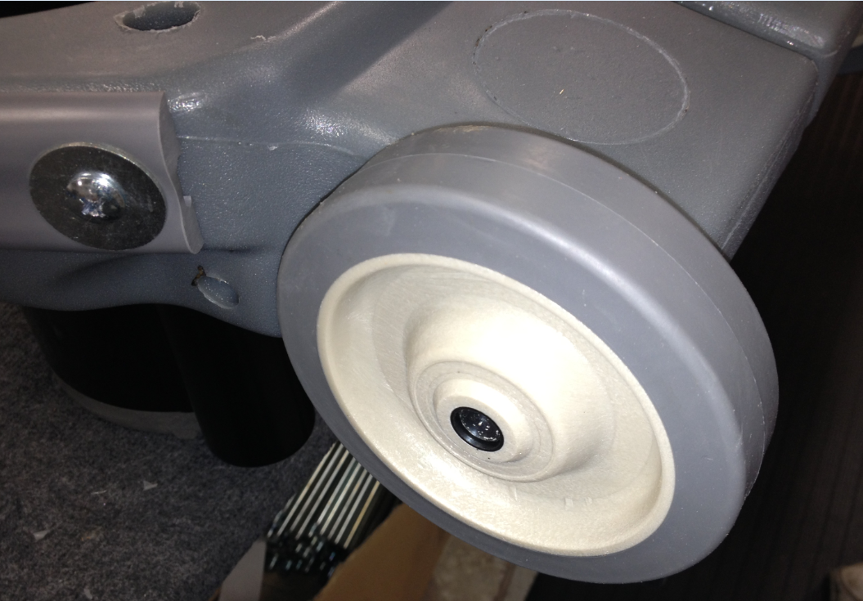

  - Use the installation tool provided and hammer an axle cap (83143) onto each end of the axle. This will hold everything on.

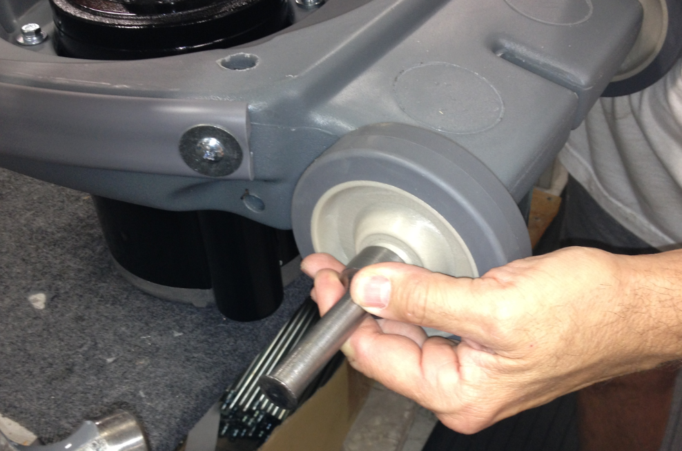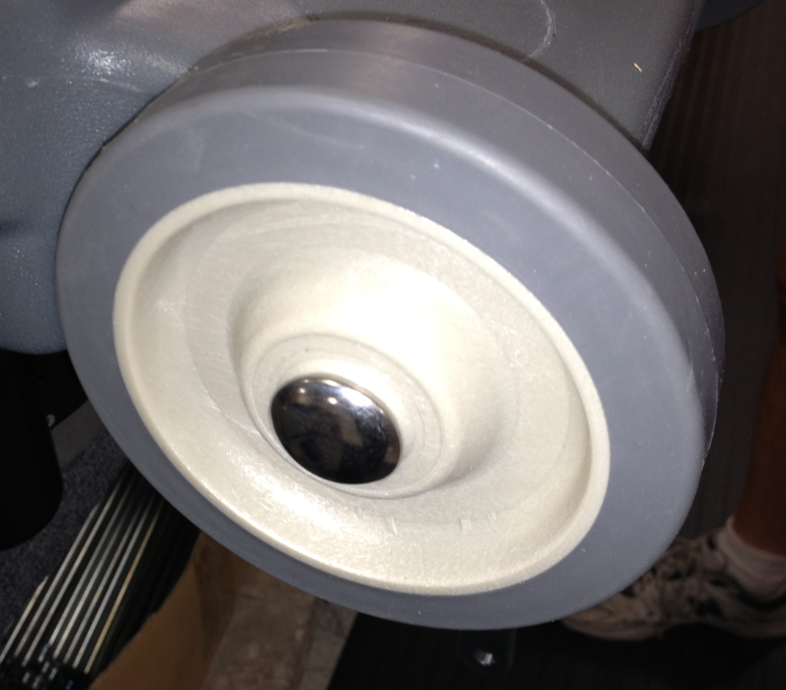

  - Take a roll of plastic wrap and wrap the wheels. This will keep them clean until the customer receives the machine.

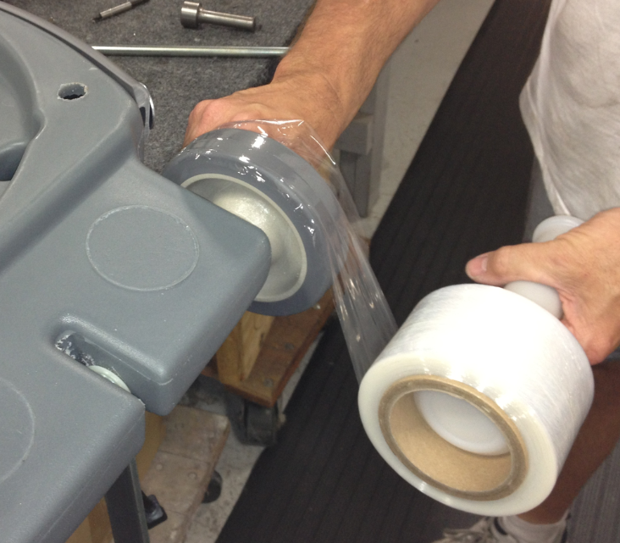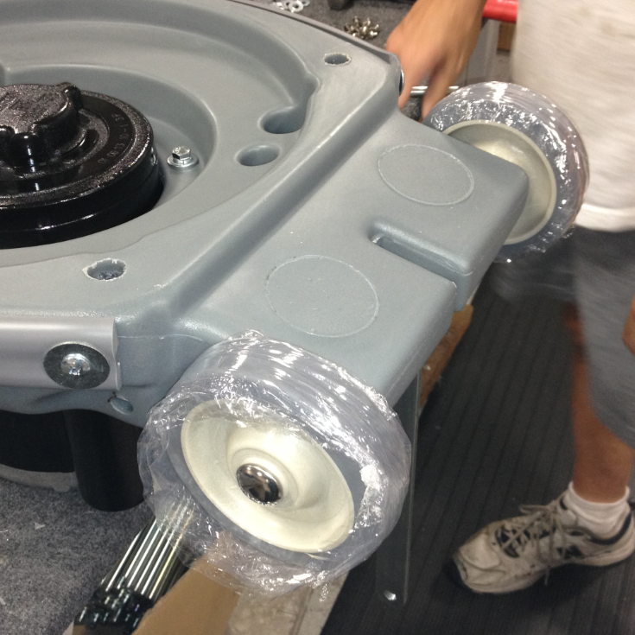

  - Flip the machine base over so that the motor is on top.

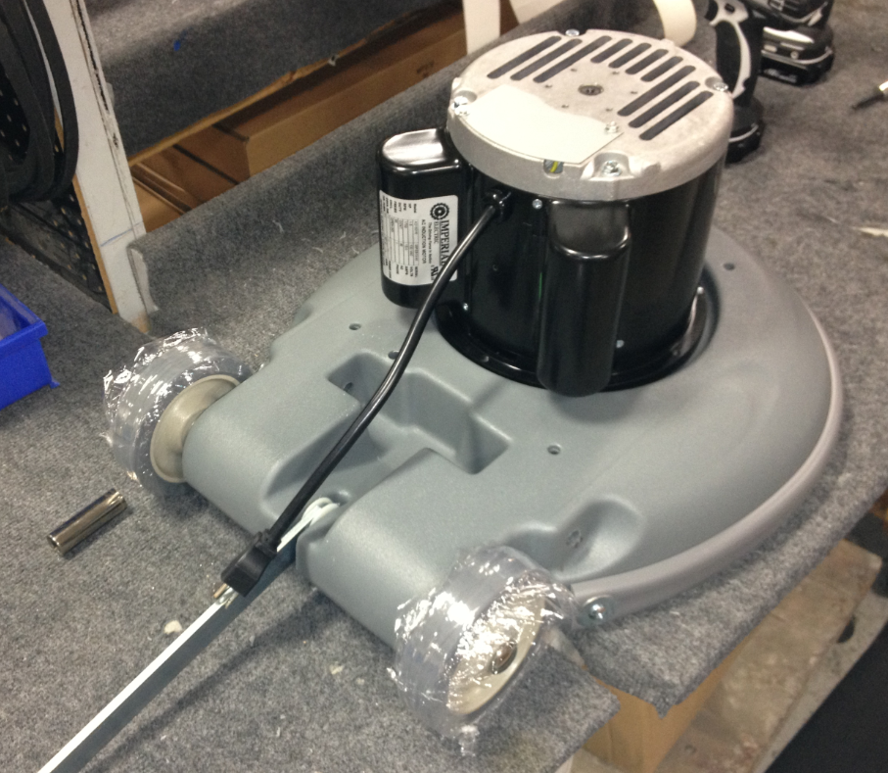
  - If the machine is to be certified for sales into Canada (E083009EQM0607BE1200 and E083010EQM0607BE1200) the inside of the red motor cover needs to be coated with flame proof paint.
  - Cut 2 pieces of black wire (E89986) that are 14” long. Strip both ends of the wire. Crimp a E89987 piggyback terminal to one end of each wire. Crimp an E12254 terminal onto the other end of each wire
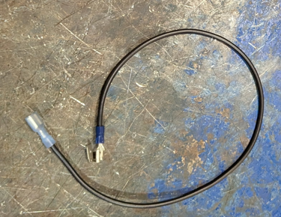

  - Take a rocker switch (E89991) and connect one of the black wires with the piggyback terminal to the middle terminal on the side of the switch with the lettering. Orient it so the piggyback terminal points to the middle of the switch.

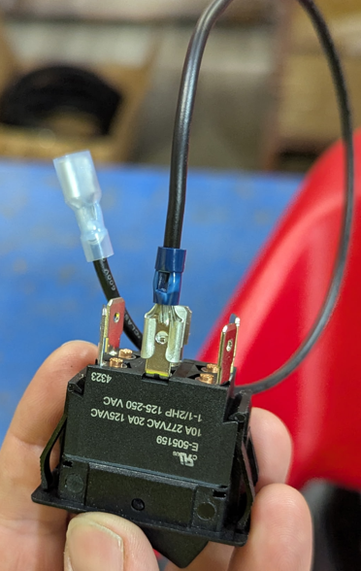
Lettering Side

  - Place a red cover (E83642) over the motor and feed the wires from the motor through the cutout shown.
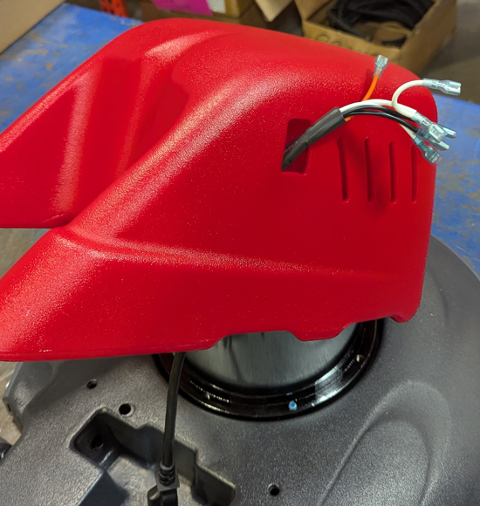
  - Connect the longer black wire on the motor harness to the piggyback terminal.
  - Connect the remaining black wire and the orange wire from the motor harness to the switch in the locations shown.

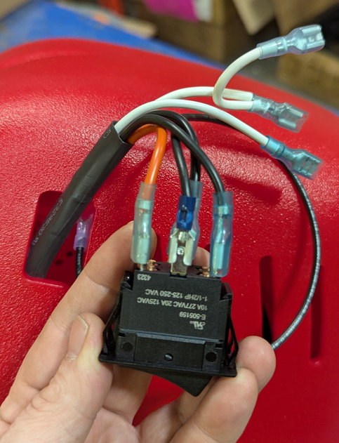
Shorter Black
Longer Black Wire on Piggyback
Orange

  - Flip the switch over and connect the white wire (with the 2 wires spliced together) and the jumper white wire onto the terminals shown.

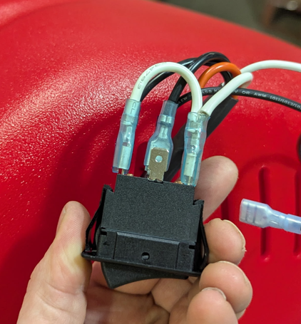
Jumper
From Motor
  - Connect the 2nd black wire (that was made previously) to the middle terminal as shown. The piggyback terminal should point towards the middle of the switch.

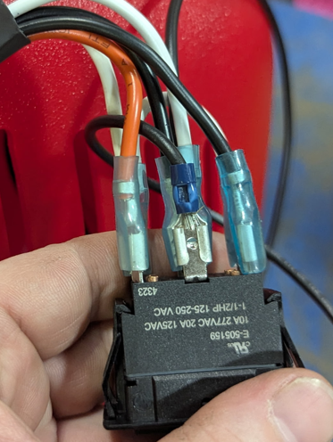

  - Connect the remaining white wire from the motor harness to the piggyback terminal.

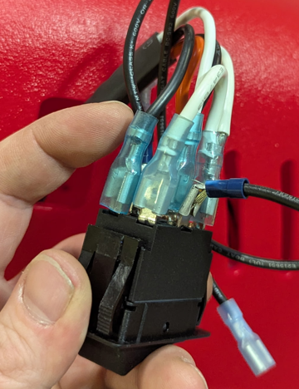

  - Feed the open ends of the 2 black wires into the red cover. Tuck the machine harness back into the red cover as well.

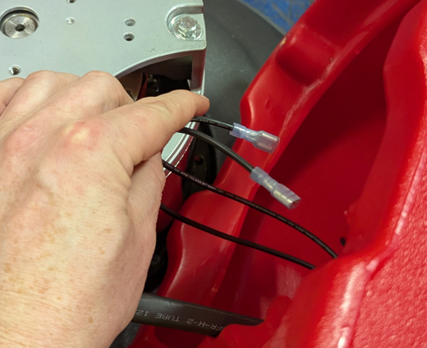

  - Pull the two black wires through the rectangular cutout on the other side of the cover as shown.

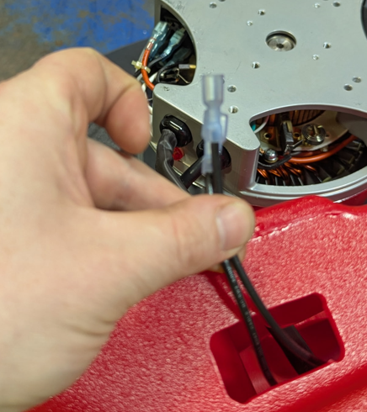

  - Connect the black wires to the terminals on the back of an hour meter (E86119). It doesn’t matter which wire connects to which terminal. Snap the hour meter into the cutout to secure it.

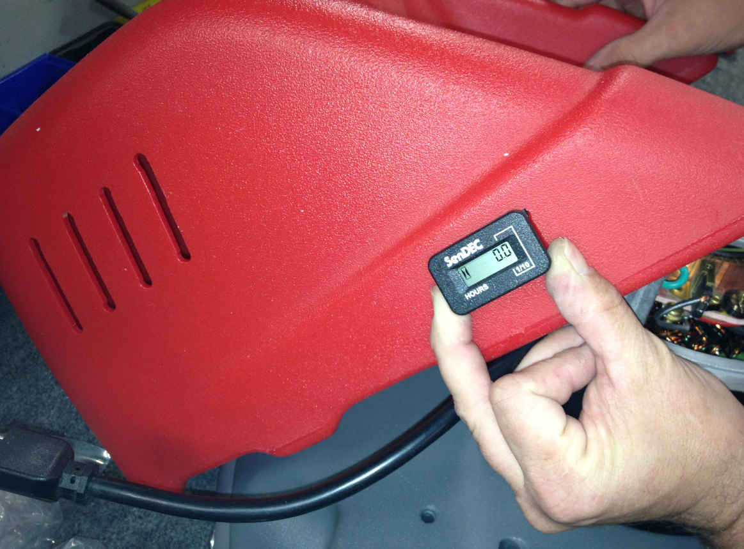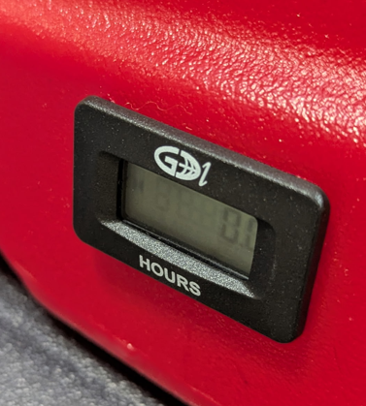
  - Snap the rocker switch into the cutout in the cover.

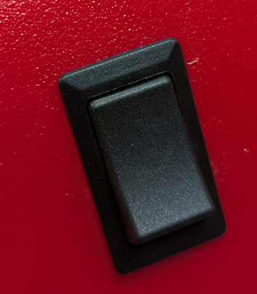

  - Position the red cover into place and route the motor power cord out of the back as shown.

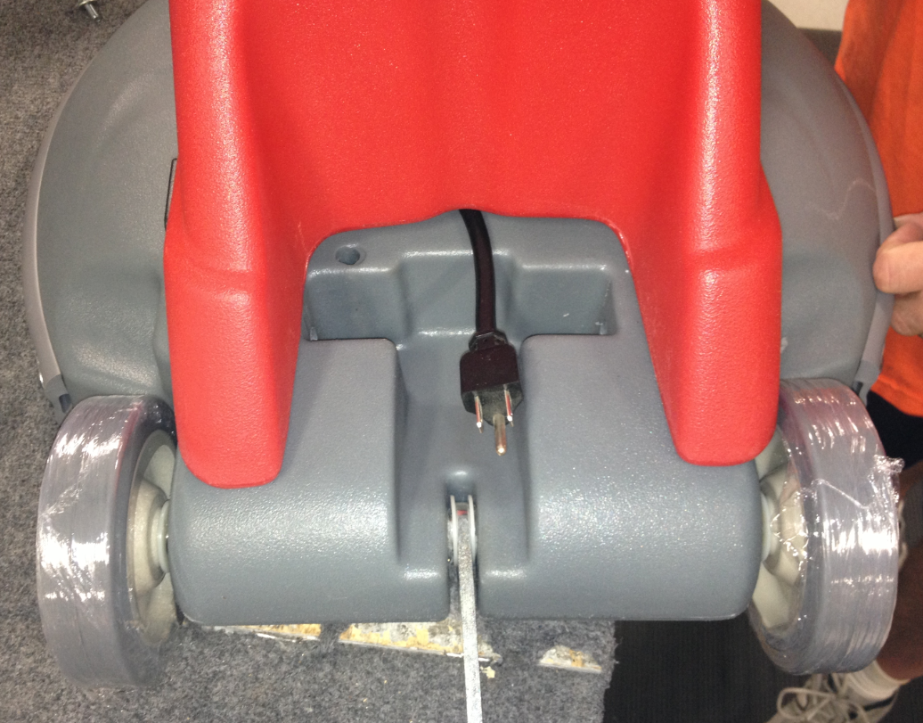

  - Flip the base over so that it is sitting on the red cover. Place a piece of cardboard on the table so that the cover doesn’t get scratched.
  - Fasten the red cover to the base using 4 screws (83570), 4 lock washers (81078), and 4 flat washers (81713). This may take two people. Sometimes the holes do not line up very well.

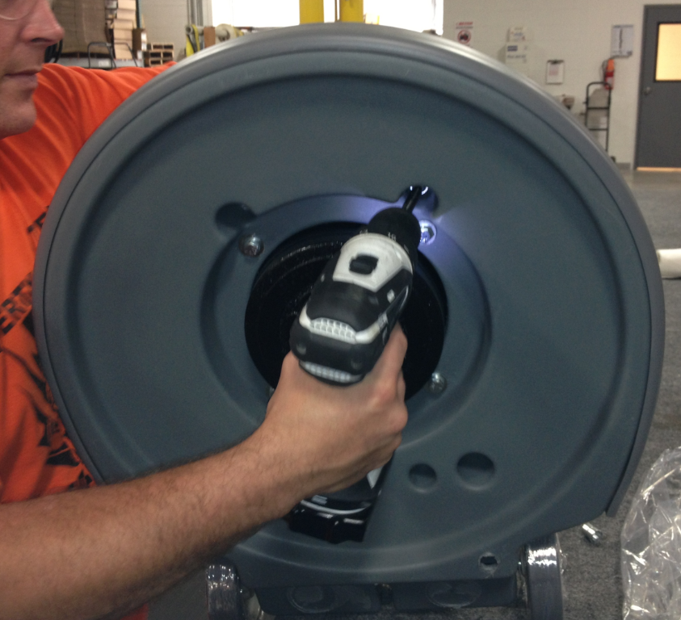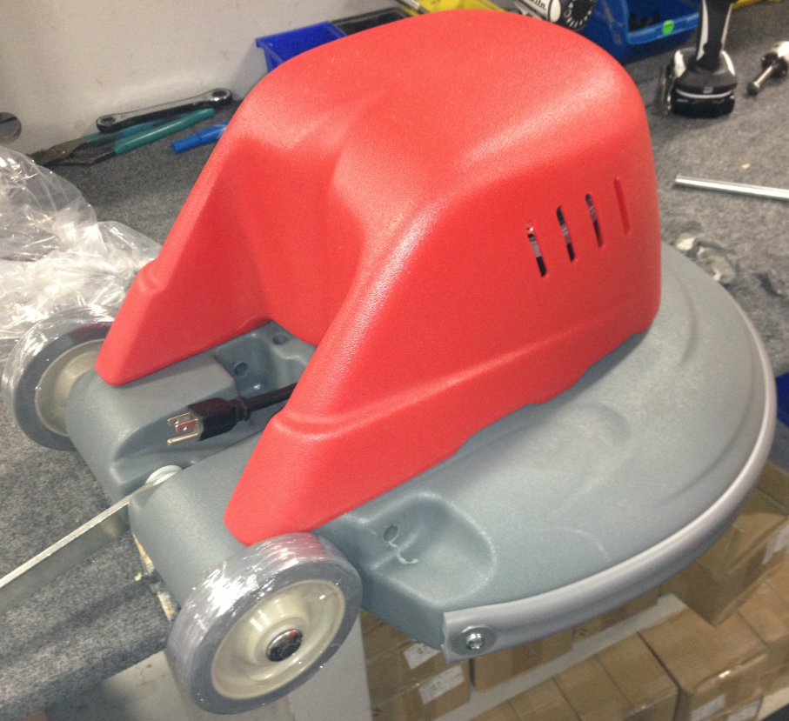
  - Flip the base back over so that it is sitting flat. Use an extension cord to test that the motor works. Be careful doing this because you are connecting it to direct current and it will immediately spin.

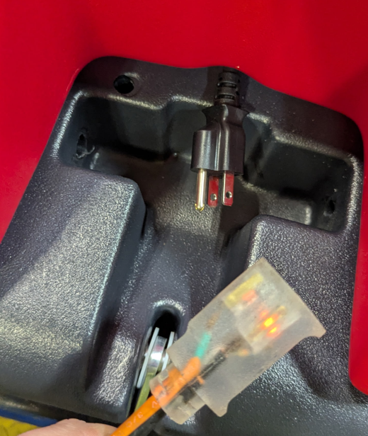

  - Take another axle (83452) and partially install it into the base in the location shown. Install it until the end just sticks into the cutout in the middle.

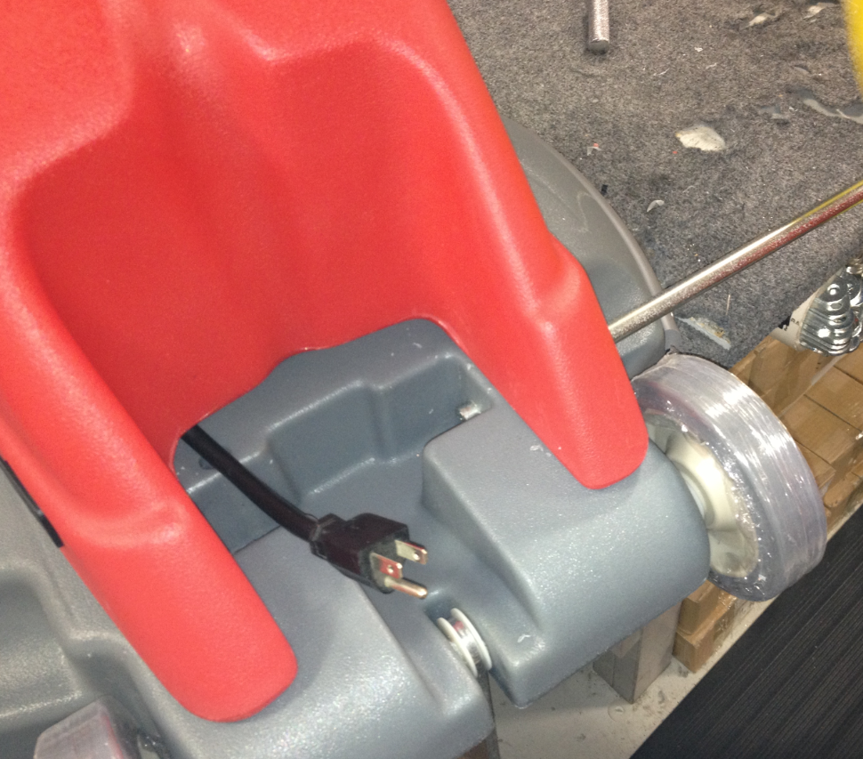

  - Assemble a handle. For assembly instructions, refer to SOP EQ 051.
  - Place the T-attachment end of the handle into the cutout in the base. Install the shaft through the base and through the T-attachment. This will hold the handle in place.

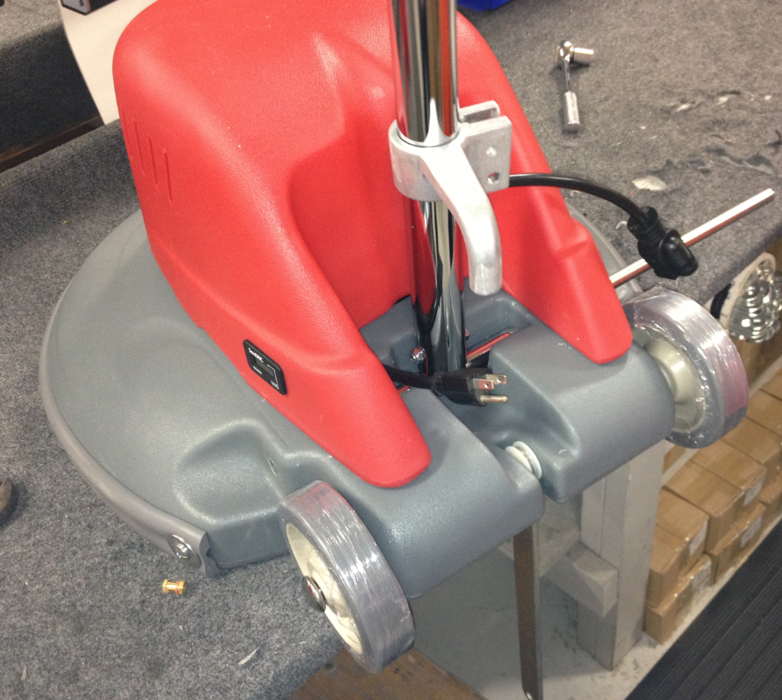

  - Once the handle is installed and centered. Install an axle cap (83143) on each end of the shaft.

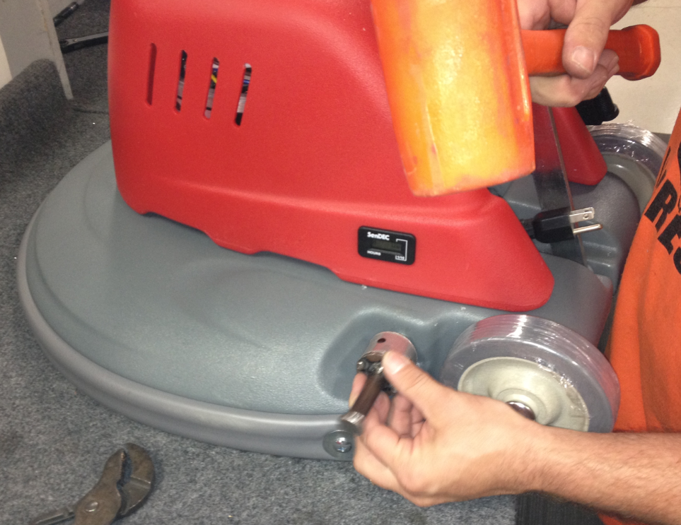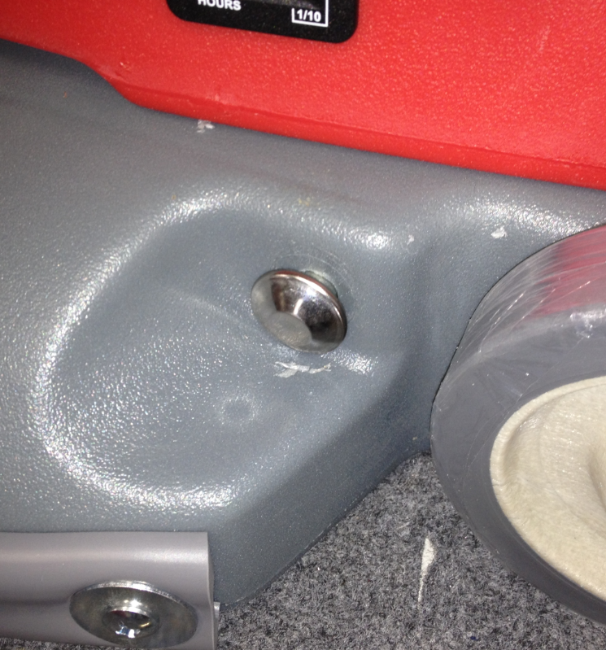

  - Plug the handle cord into the motor cord.

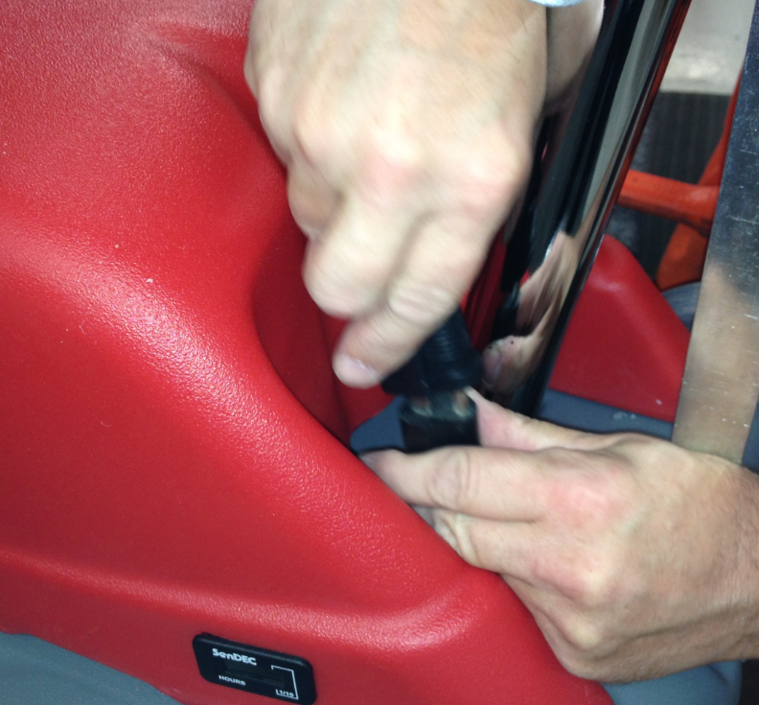

  - Secure the strut to the cord wrap using a shoulder bolt (81077) and a nut (81063).

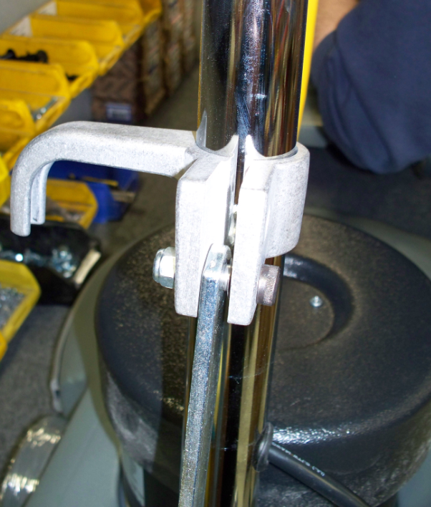
Bolt
Nut

  - Assemble the cam handle using the following components: 1 cam handle (83133), 1 oval washer (83135), 3 nylon washers (83145), and 1 nut (81063). The oval washer presses onto the similar profile on the stem of the cam handle. Note the order of the parts below.

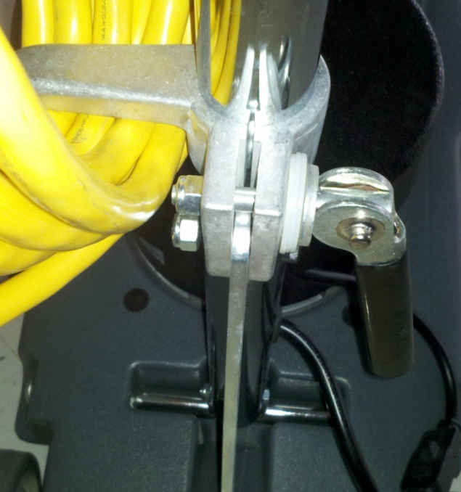
Nut
Nylon Washers
Oval Washer
Cam Handle

  - Tighten the nut enough so that the cord hook slides easily up and down the handle shaft when the cam is released and holds the base and handle tight when the cam is engaged.
  - The machine assembly is now complete and ready for testing.

- References (optional section as needed)

- Training Guide

Functional Training Groups Requiring Training
Equipment Group

- SOP Change Control

Date of Change | Reason for Change
Rev 01 - 11/22/2013 | This is the first version of the S.O.P. hence there are no revisions to this document.
Rev 02 - 1/12/2018 | Updated the SOP with various changes. Added the Responsibilities section
Rev 03 - 5/15/2019 | Changed the quantity of 83145 on the cam handle from 1 to 3. jb
Rev 04 – 11/14/2025 | Updated for new switch location in the cover rather than the handle

Approvals

Submitter/Author Approval: 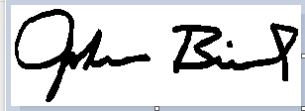Date:______5/15/2019________________

Management Approval: Date:________5/15/2019______________

QAU Approval: Date:_________5/15/2019_____________

